2/25 Lesson Plan – Tone in Mary Oliver’s “In Blackwater Woods” – Howard
Standards (CCSS):
W.9-10.9, RL.9-10.1, RL.9-10.2, RL.9-10.4, SL.9-10.4, L.9-10.5
Objectives:
SWBAT closely read a literary text to determine how the author uses specific word choice and figurative language to evoke a specific tone and address a central idea
SWBAT identify and present evidence from a text to clearly, concisely, and logically support explicit and implicit analysis
Materials:
- Projector/Slides OR Chart paper with instructions and expectations
- Packet with student materials
- BT speaker for transition signal
- Paper for name cards
- Images for Hook (Soldier and Banksy)
Plan:
Hook:
- What do these two pictures have in common? How are they different?
- Ss. share with a partner, then 2-3 with whole class
Direct Instruction:
- Q: “Who can tell me what tone is?”
  - Looking for: the way something sounds, feelings, author’s thoughts, etc
- T. will provide examples of tone of voice (angry, excited) and distribute packet
- Ss. will copy definition of tone: In writing, tone is the speaker’s attitude toward the subject of the text.
- Q: “So what do we need to discover the tone?”
  - Looking for: the subject of the text and hints (context clues) about how the speaker feels about it
- Ss. will identify speaker’s attitude as an adjective and subject of the text as a noun.
- Check for understanding:
  - Look back at hook. What is the subject of the image? What is the tone?
  - Looking for: subject is a noun (army, soldier, war), tone is an adj. (patriotic/respectful vs.
Guided Practice:
- 1st Read - Gist
  - T. will read poem to class
  - Ss. will follow along, annotating for reactions (!, ?)
  - Ss. will share with partner 1 thing they noticed, then 1-2 Ss. share with class
  - Check for Literal Understanding (#1):
    - In 3-5 words, what is this poem about (on the surface)
    - Looking for: fall, life lessons, nature (trees, ponds), etc
- 2nd read – Analysis
  - Q: “What are the five senses?”
  - Ss. will read the poem again independently, highlighting sensory images
  - Check for Analytical Understanding (#2):
    - Ss. turn to a partner, share one image, then, 2-3 share partner’s image with class
    - Looking for: “bodies into pillars…”, “rich fragrance…”, “cattails bursting…”, “blue shoulders…” etc
- 3rd Read – Conceptual
  - Ss. will read the poem again, annotating any new understandings that arise (T. models his text)
  - After 3rd read, Ss. will independently answer the following question in writing:
    - In the poem, Oliver reveals her tone through specific images. What kind of tone does she take? Use specific evidence from the text to support your answer.
  - After Ss. have answered independently, T. will guide dissection of question (“What 3 steps do we need to be able to answer this question?”). Looking for: find images, find subject, use context clues to find tone
  - Ss. will ID where the subject/central idea is revealed and what it is, share
  - Check for Understanding #3:
    - Make a list of 3 or more words/phrases from the poem that address the subject
    - Looking for: specific evidence pointing to subject we discussed
Exit Ticket:
Ss. will complete “MadLib” Exit Ticket:

In her poem “In Blackwater Woods”, Mary Oliver addresses the subject of _______________ (noun). She conveys her feelings about it through the use of specific words and phrases like _______, _________, and _________, which reveal her _______________(adj) tone.

If time, Ss. will share responses with class
Next Steps/Extension:
- If time after 3rd read, students will revise their answers to the question using information from the discussion
- For students who finish early, space on back to tell me why they love being a KIPPster.
- Homework/Extension Options:
  - What is your attitude toward loss? Compose a short narrative or poem in which you convey your feelings (tone) about the subject of loss. Be sure to think about how imagery and figurative language play into the development of tone.
  - Choose another poem from a list provided and identify the tone in that poem by highlighting specific words/phrases. Write a short analysis of the impact of word choice on tone in that poem.
    - Poem options:
      - On Hatred – Rudy Francisco
      - Mad Girl’s Love Song – Sylvia Plath
      - To Helen About Her Hair – Robinson Jeffers
      - Screech Owl – Ted Kooser
      - Self Pity – D.H. Lawrence

Materials on following page:

Name: ______________________________
Objective 1 – I can closely read a literary text in order to determine how the author uses specific word choice and figurative language to evoke a specific tone and address a central idea
Objective 2 – I can identify and present evidence from a text in order to clearly, concisely, and logically support explicit and implicit analysis
What Does Your Tone Say About You?

Think about how you speak every day. Place an “X” in the boxes that best describe your tone of voice.

 | High | Medium | Low
Volume | I speak pretty loud | I speak at a normal volume | I’m pretty quiet
Articulation | I speak very clearly | I speak clearly enough | I often am unclear or mumbling
Speed | I speak pretty fast | I speak at a normal speed | I speak pretty slowly

Do you agree with the analysis of your tone?

Close Reading and Tone
Objective 1 - SWBAT closely read a literary text to determine how the author uses specific word choice and figurative language to evoke a specific tone and address a central idea
Objective 2 - SWBAT identify and present evidence from a text to clearly, concisely, and logically support explicit and implicit analysis

In the space below, copy the definition of tone exactly as it appears on the board

Below is a handy tool for choosing accurate tone words. When naming a tone, be specific!
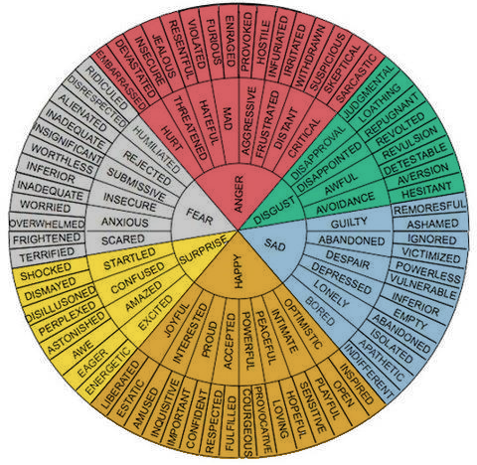

“In Blackwater Woods”
Use this space to respond to Check for Understanding #1:
by Mary Oliver

Look, the trees
are turning
their own bodies
into pillars

of light,
are giving off the rich
fragrance of cinnamon
and fulfillment,

the long tapers
of cattails
are bursting and floating away over
the blue shoulders

of the ponds,
and every pond,
no matter what its
name is, is

nameless now.
Every year
everything
I have ever learned

in my lifetime
leads back to this: the fires
and the black river of loss
Use this space to respond to Check for Understanding #3:
whose other side

is salvation,
whose meaning
none of us will ever know.
To live in this world

you must be able
to do three things:
to love what is mortal;
to hold it

against your bones knowing
your own life depends on it;
and, when the time comes to let it
go,
to let it go.
In the poem, Mary Oliver reveals her tone through specific images. What kind of tone does she take? Use specific evidence from the text to support your answer.

After the discussion, please revise and improve your response!

In the poem, Mary Oliver reveals her tone through specific images. What kind of tone does she take? Use specific evidence from the text to support your answer.

Exit Ticket – Mad Libs!

Fill in the blanks below with responses that are based on the text.

In her poem “In Blackwater Woods”, Mary Oliver addresses the subject of __________________________.
(noun)
She conveys her feelings through the use of specific words and phrases like: ____________________ _________________________________________________________________________________, _________________________________________________________________________________, and _________________________________________________________________________________, which reveal her _______________________________________________________________ tone.
(adjective)

Finished early? Use the space below to tell me what you like most about your school:

